Nathan Bemus

ECCS 4361

Homework 3

9/26/17

Task 1:

This is the original image uploaded to Matlab.

A = imread('xrayLefthand', 'jpg');

A = A(:, :, 1);

A = double(A);

figure(1);

imshow(A, [min(min(A)), max(max(A))]);

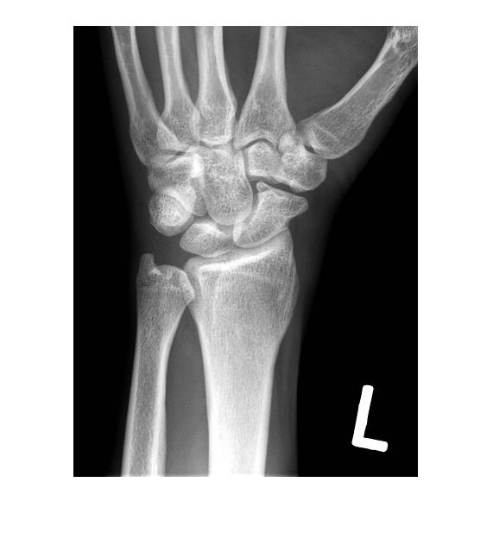

This is the image with the Lapacian Filter being used on the original image.

figure(2);

LF = fspecial('Laplacian');

B = imfilter(A, LF);

imshow(B, [min(min(B)), max(max(B))]);

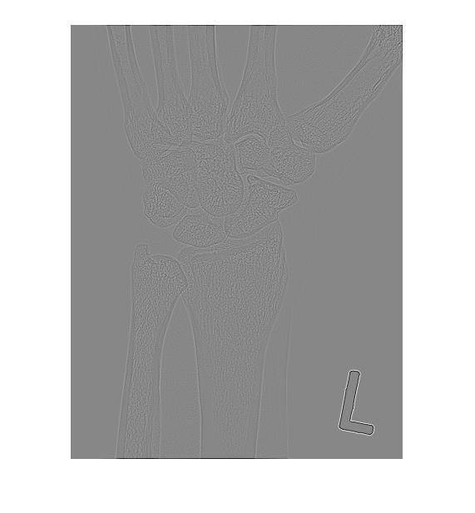

This is the image after adding the results from B with the original image A.

figure(3);

C = A + B;

imshow(C, [min(min(C)), max(max(C))]);

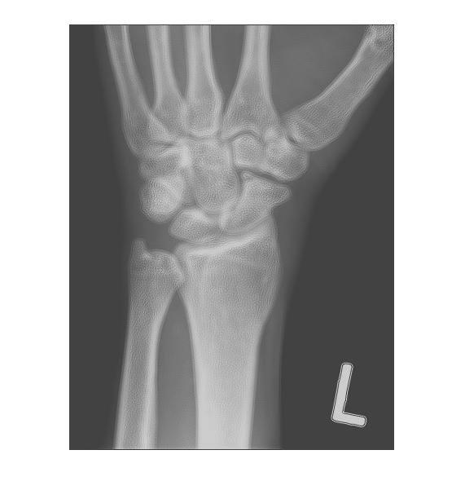

This is the Sobel gradient of the original image A.

figure(4);

SF = fspecial('Sobel');

D = imfilter(A, SF);

imshow(D, [min(min(D)), max(max(D))]);

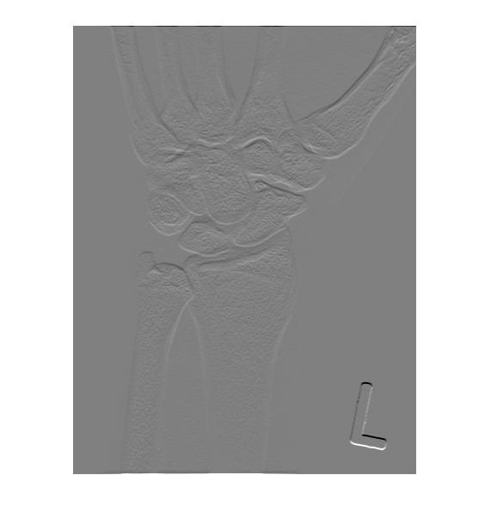

This is the resulting product for point multiplying images E and C.

figure(5);

E = imgaussfilt(D, 5);

imshow(E, [min(min(E)), max(max(E))]);

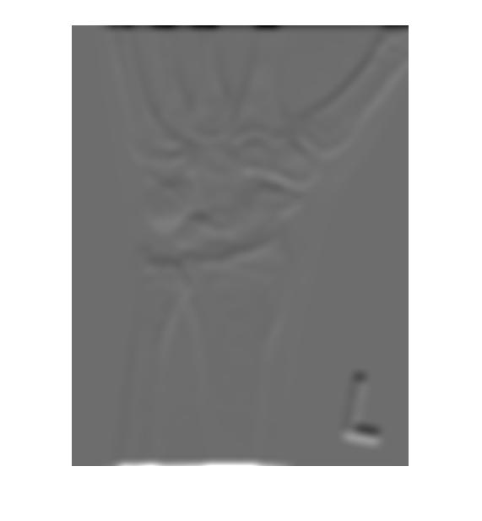

This image is the result of adding image A and Image F.

figure(7);

G = abs(A) + abs(F);

imshow(G, [min(min(G)), max(max(G))]);

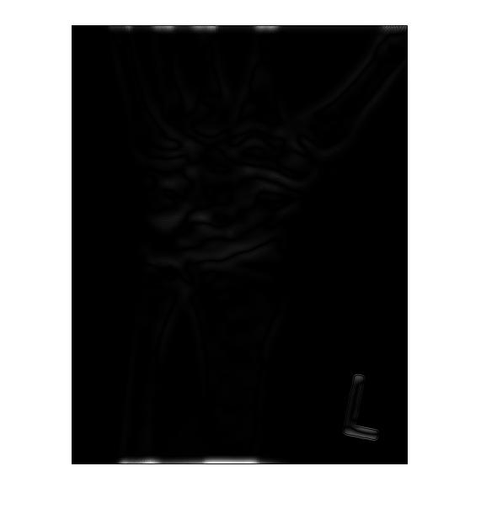

This is the result of the power law or gamma correction on image G with the matlab code.

figure(8);

GC= A / max(max(A));

Gamma = .5;

Constant = 256;

H = Constant .\* GC .^ Gamma;

imshow(H, [min(min(H)), max(max(H))])

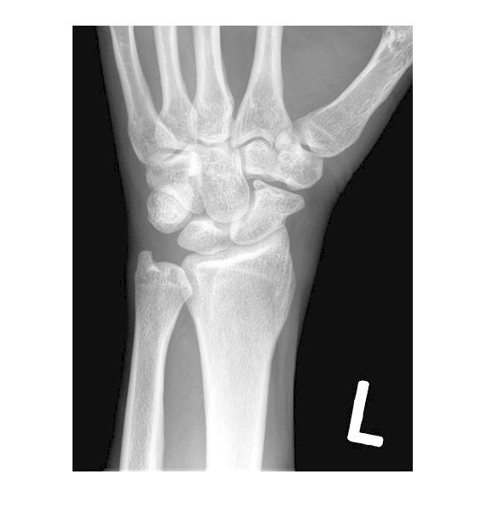

Task 2:

im = imread('lowPenguin.jpg');

im = im(:, :, 1);

[x, counts] = imhist(uint8(im));

stem(counts, x);

dark = 45;

gray = 80;

bright = 115;

vd = 50;

vg = 125;

vb = 200;

im = double(im);

mem = zeros(192, 267, 3);

enhanced = zeros(192, 267);

for i = 1:192

for j = 1:267

if im(i,j) <= dark

mem(i, j, 1) = 1;

elseif im(i, j) <= gray

mem(i, j, 1) = 1 - ((im(i,j) - dark) / (gray - dark));

mem(i, j, 2) = 1 - mem(i, j, 1);

elseif im(i, j) <= bright

mem(i, j, 2) = 1 - ((im(i,j) - gray) / (bright - gray));

mem(i, j, 3) = 1 - mem(i, j, 2);

else

mem(i, j, 3) = 1;

end

enhanced(i,j) = ((mem(i, j, 1) \* vd) + (mem(i, j, 2) \* vg) + (mem(i, j, 3) \* vb)) / (mem(i, j, 1) + mem(i, j, 2) + mem(i, j, 3));

end

end

%Display New Image

figure(2);

imshow(uint8(enhanced));